Readout from SARCOF 33 Meeting of 25th-28 August 2026
- LAST SEASON PERFORMANCE OND 2025 – JFM 2026
OND 2025/JFM2026 Rainfall Performance
Drought Indicator (SPI-3)
By December 2025, the 3-month Standardized Precipitation Index (SPI3) showed dry to very dry conditions across western Angola/Namibia, central DRC, southern/south-western South Africa, and southern Madagascar. Near-normal conditions prevailed across central SADC — parts of the DRC, Zambia, eastern Angola, Botswana, Zimbabwe, southern Mozambique, Tanzania, and central Madagascar — while moderately to very wet conditions were recorded in northern Mozambique, north-eastern Botswana, central Malawi, northern South Africa, central Namibia, and northern Madagascar.
By March 2026, very wet conditions dominated much of Tanzania, north-eastern Zambia, north-eastern DRC, and southern Mozambique. Near-normal conditions persisted across much of the region, while moderately to extremely dry conditions affected western Angola, south-western Namibia, parts of South Africa, areas of the DRC, and much of Madagascar. Overall, short-term moisture conditions remained near-normal across most of the region, despite localized wet and dry anomalies.
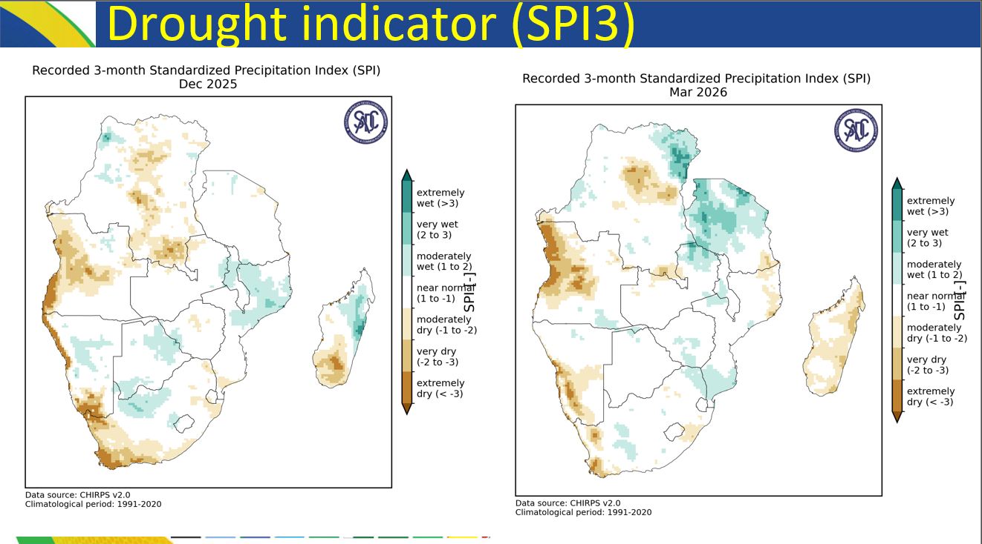

Observed rainfall performance, OND 2025 to JFM 2026
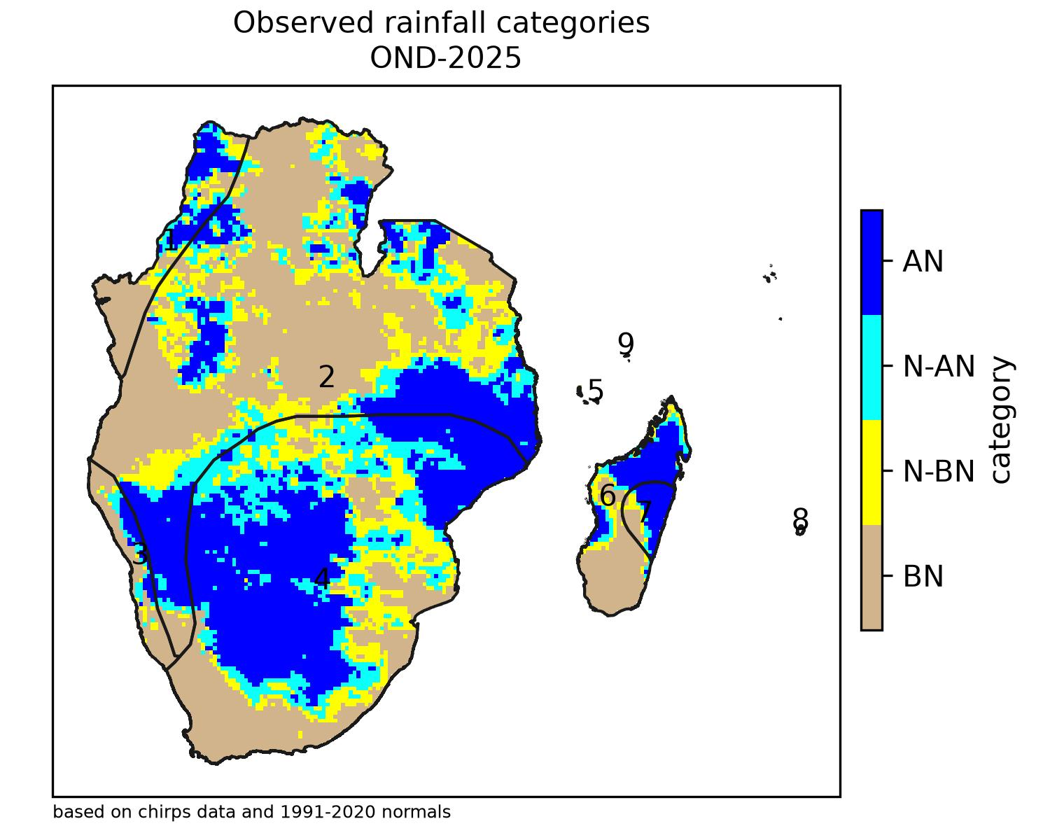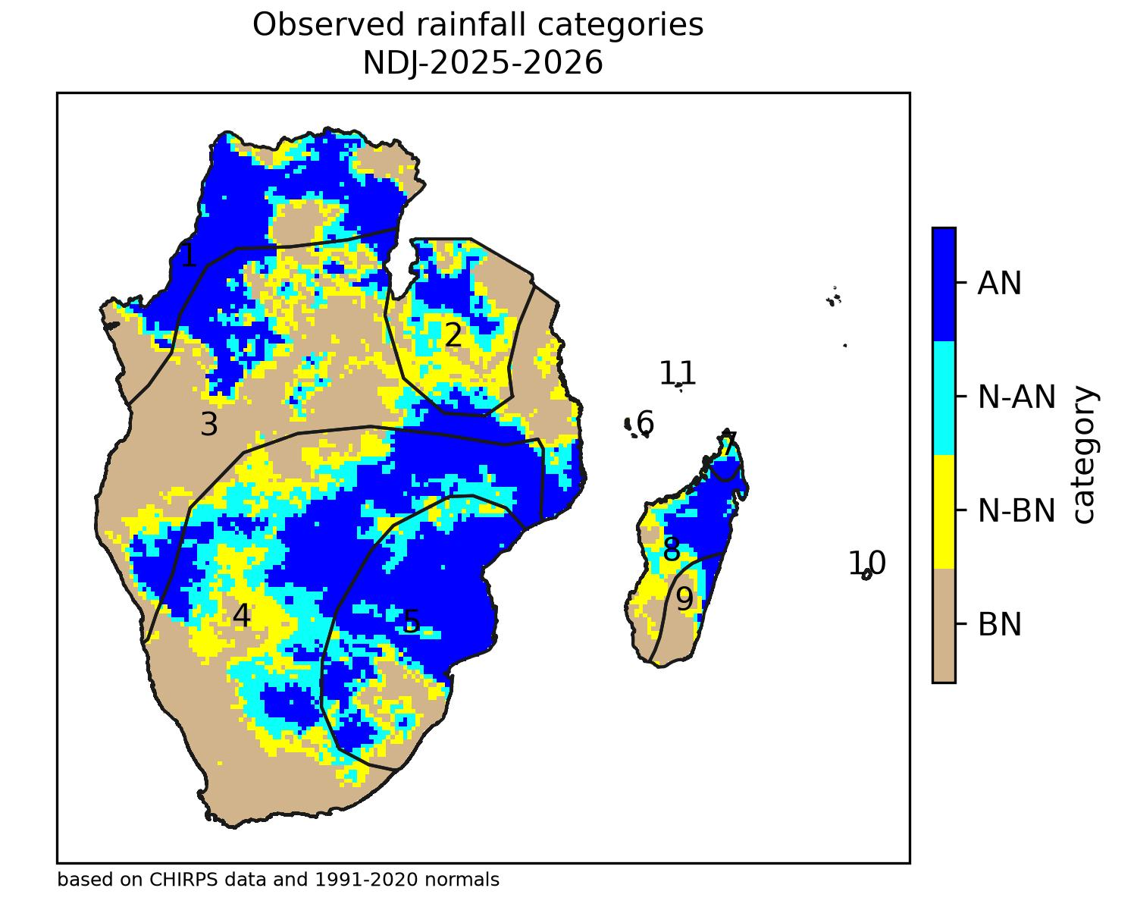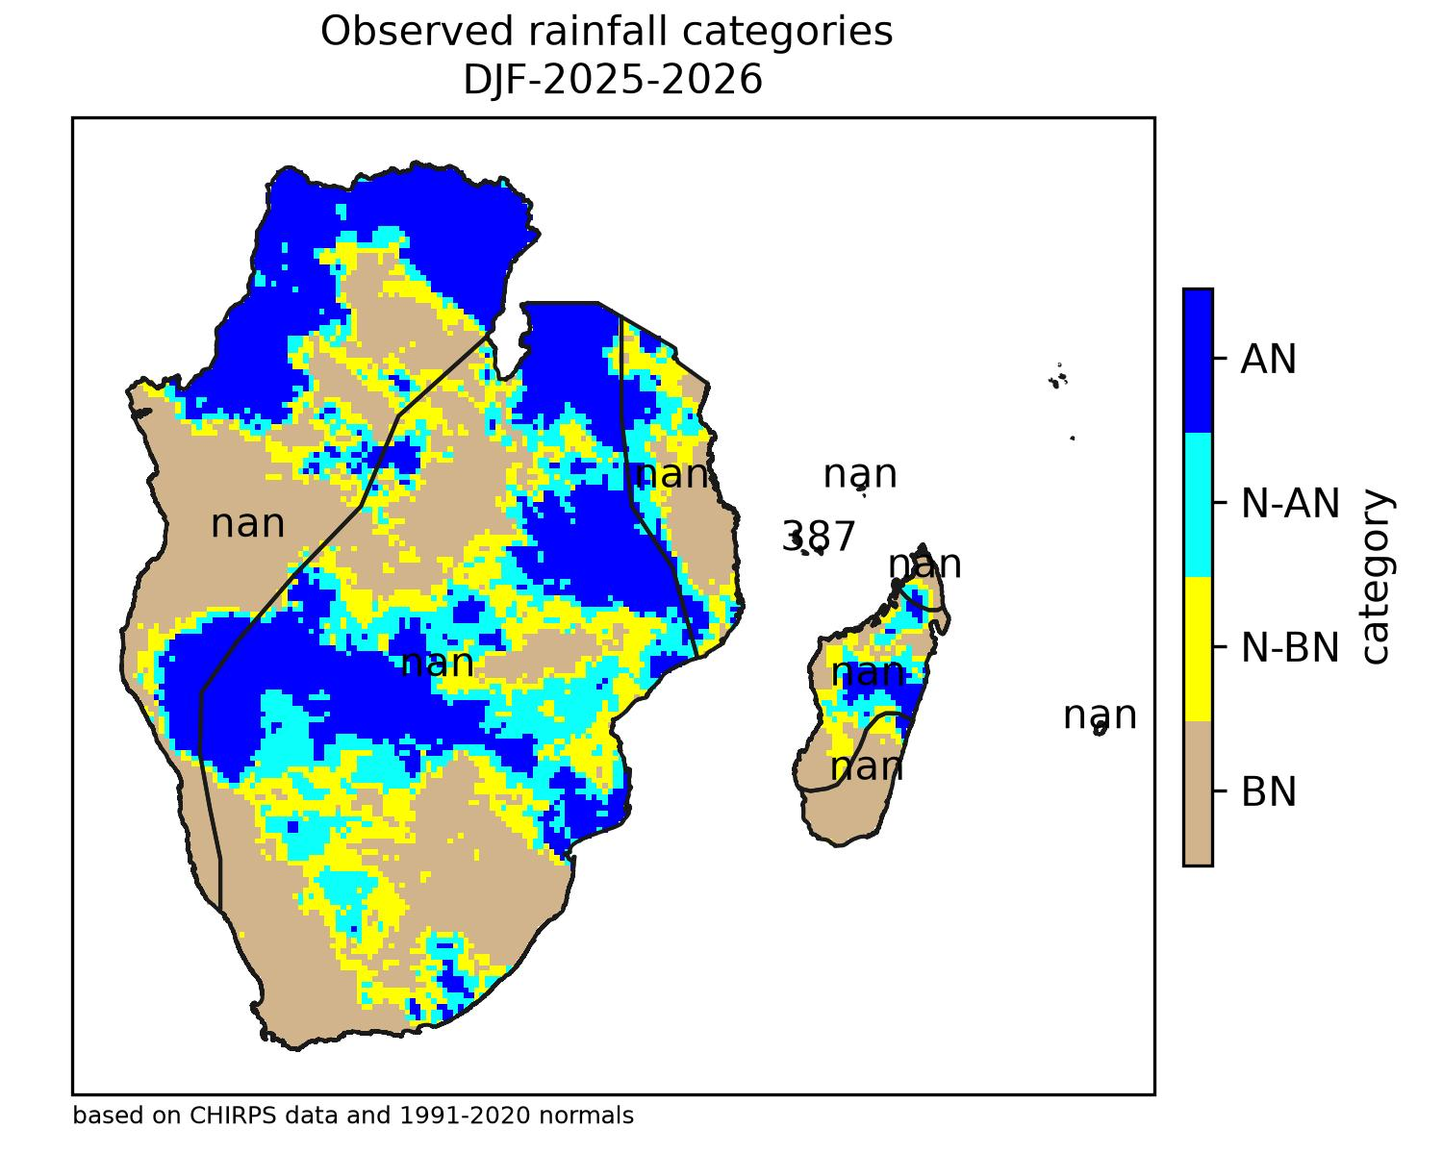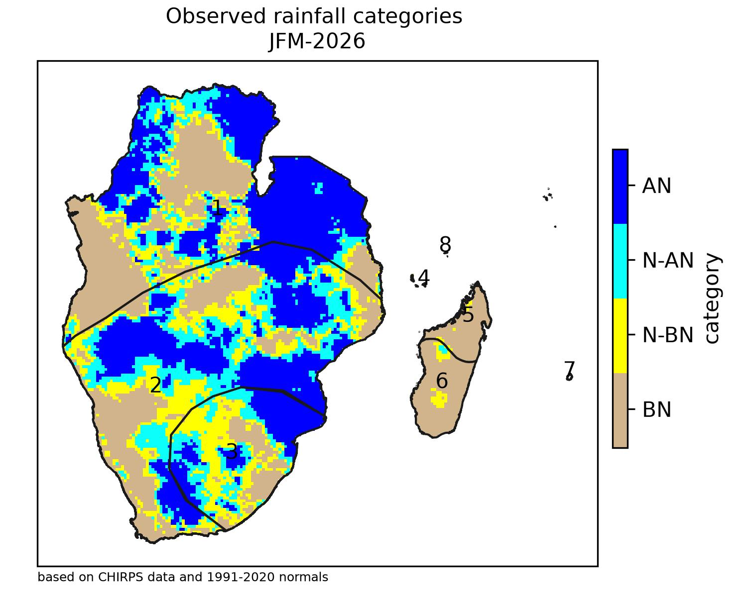

- State of the Global Climate for the Rainfall Season 2026/2027
Status of Climate drivers, 2026/27 Season
- El Nino conditions are currently established in the tropical Pacific and are expected to strengthen further, with most models indicating a strong to very strong El Nino event (>2ºC), with peak intensity expected around the OND 2026 period.
- Equatorial Sea Surface Temperatures (SSTs) are above average across the equatorial Pacific Ocean.
- Strong El Niño events are generally associated with an increased likelihood of below-normal rainfall over large parts of central and southern SADC, although rainfall across the region is also influenced by other climate drivers.
- The Indian Ocean Dipole (IOD) is currently neutral; however, the latest model guidance indicates a high likelihood of a strong positive IOD developing by September 2026 and persisting through OND 2026, before weakening towards neutral conditions in early 2027.
- Subtropical Indian Ocean Dipole (SIOD) is in positive phase (+0.5) and is projected to continue cooling

Historical Analogues
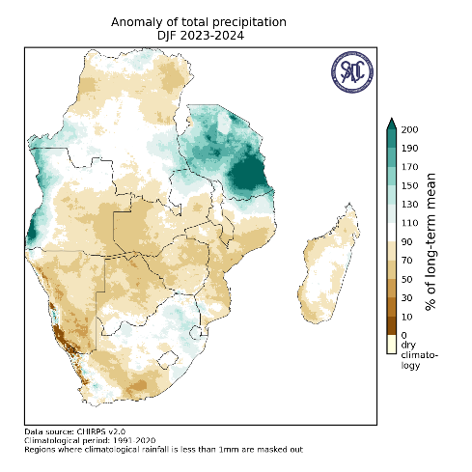
Analogue analysis of past strong El Niño DJF seasons (notably 1957/58, 1963/64, 1982/83, 1997/98 and 2023/24) was used alongside statistical and dynamical model guidance to inform the 2026/27 outlook; the 1997/98, 2015/26 and 2023/24 seasons were highlighted as the closest recent strong-El Niño analogues based on the current projected climate drivers state (Niño3.4, SOI, IOD, SIOD, TSA and TNA indices), and this indicates drier conditions in south and wetter conditions in north, but differ in location and intensity, however each event is unique.
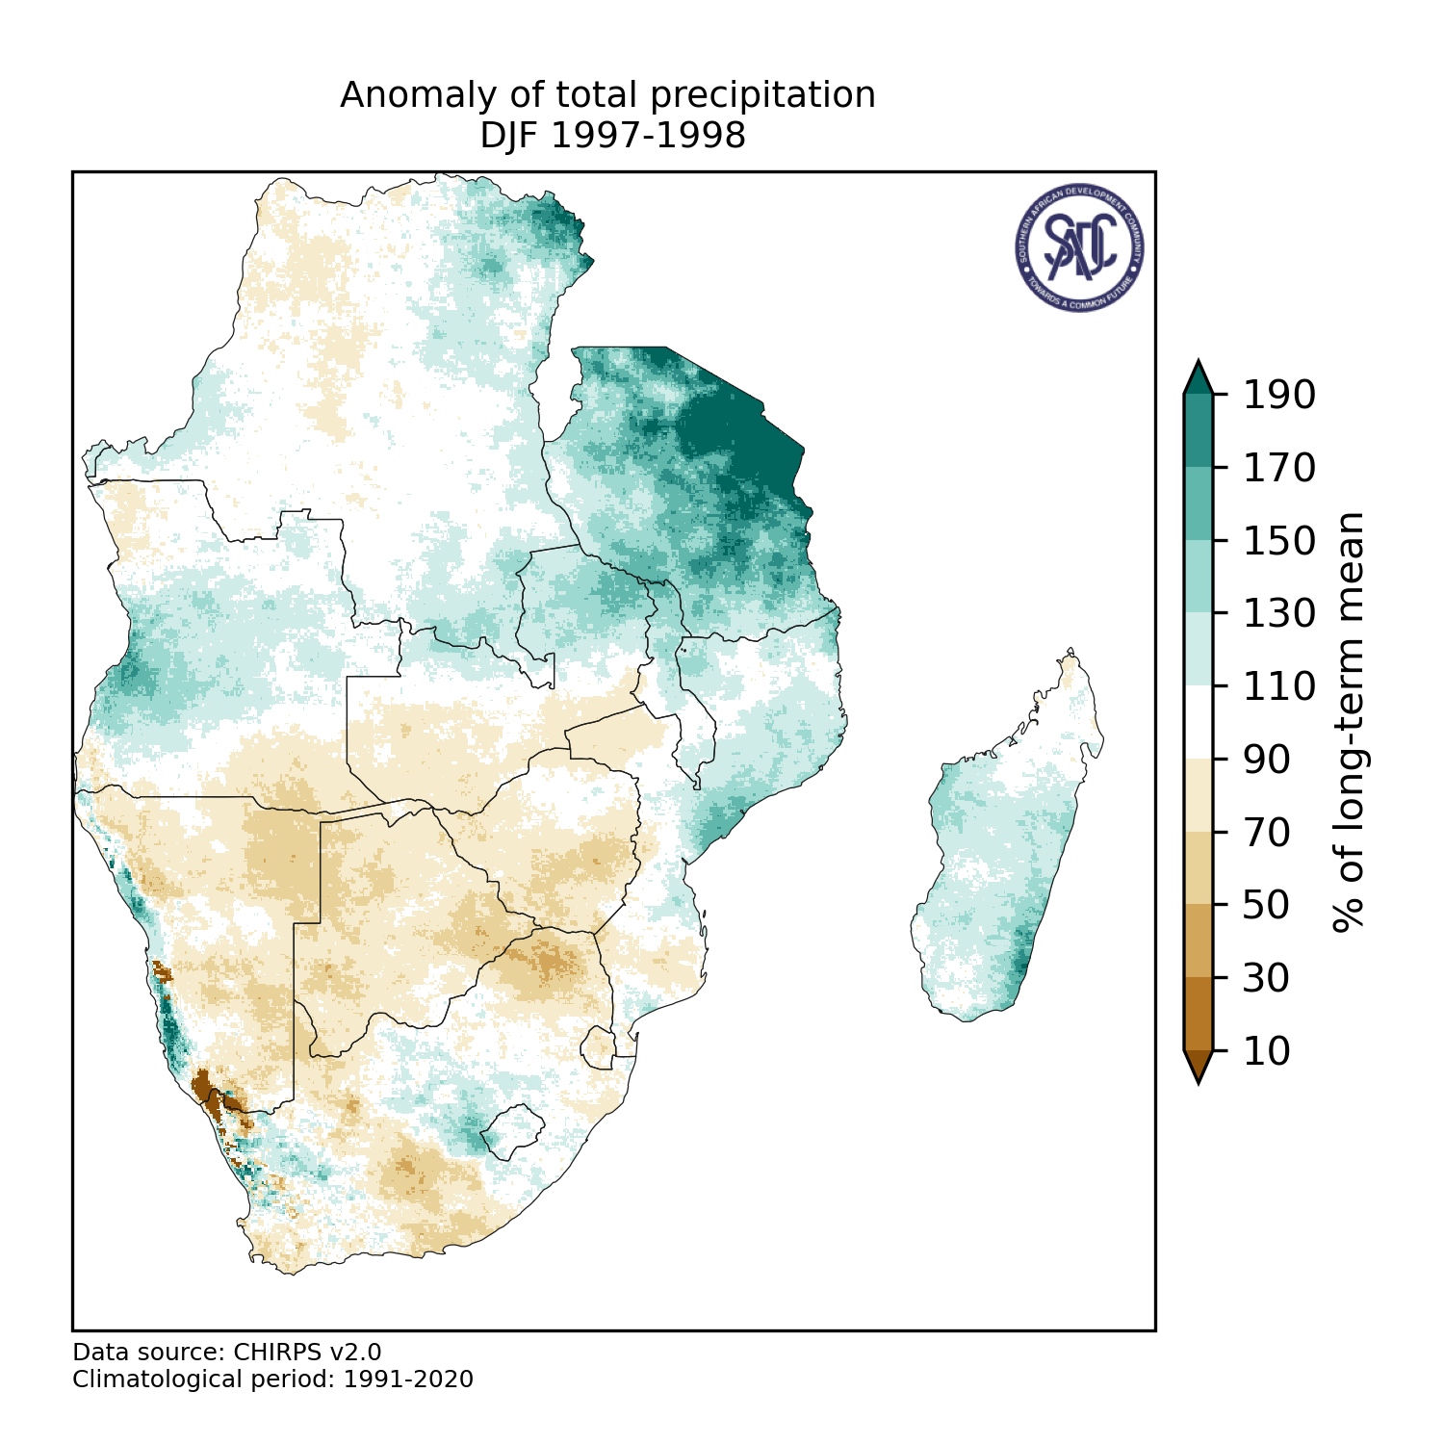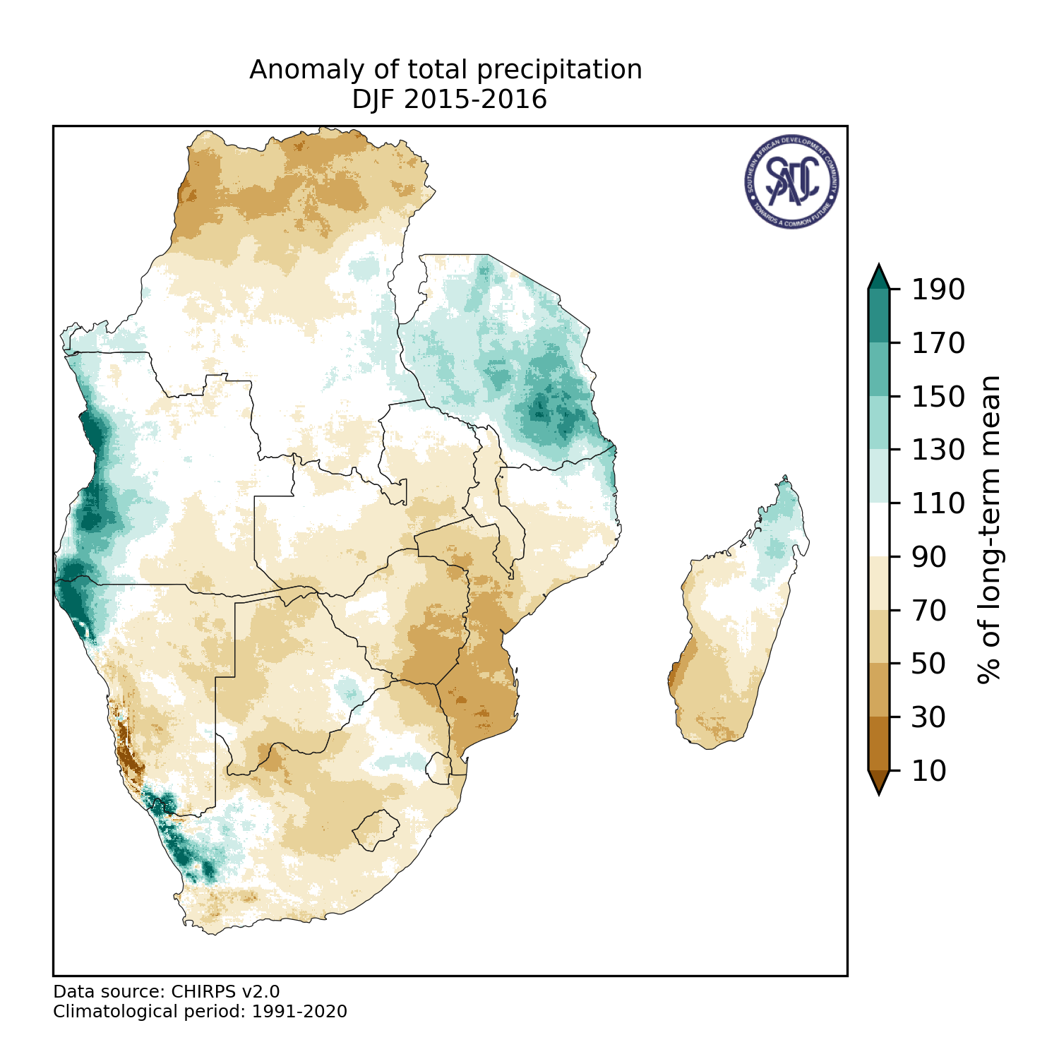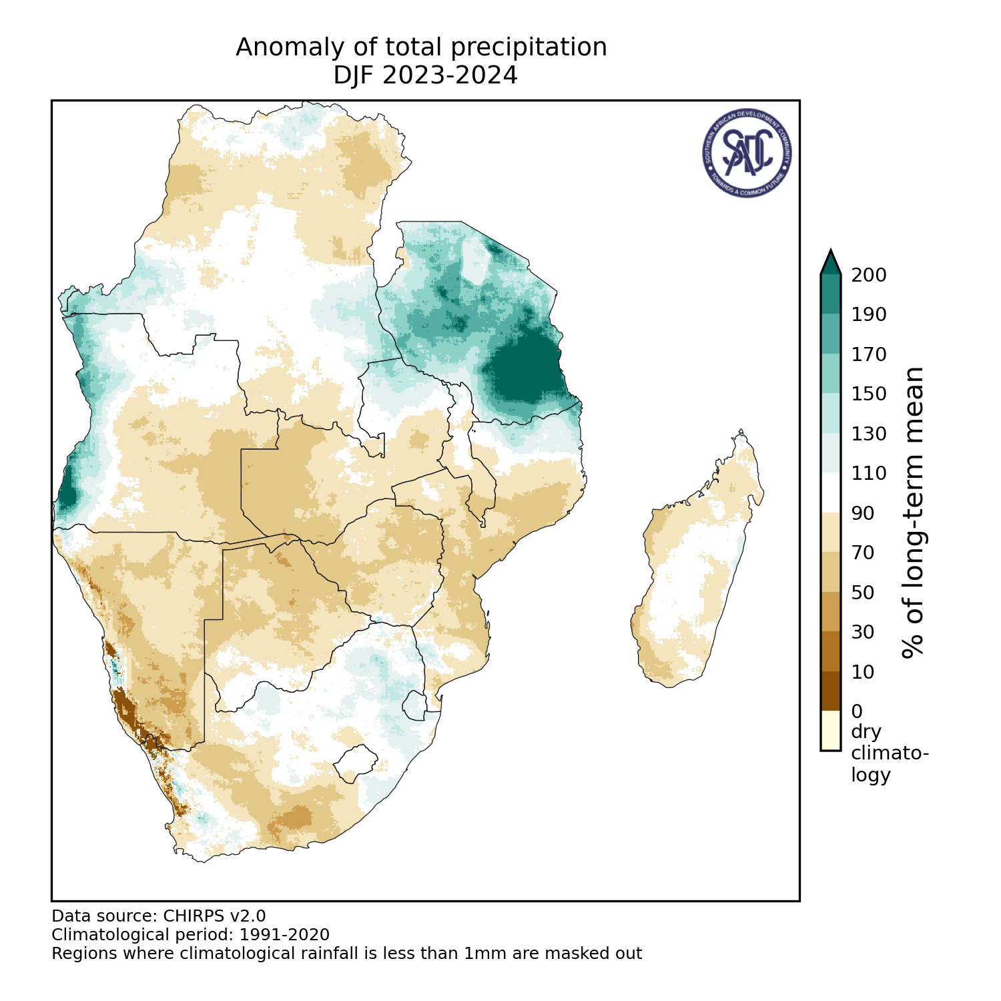

- Seasonal Outlook for OND 2026 / JFM 2027
The outlook is broadly supported by forecasts from the multi-model ensemble (MME) of Global Producing Centres (GPCs) coordinated through the World Meteorological Organization.
The MME guidance indicates an increased likelihood of below-normal rainfall over most parts of the central and southern SADC region during the 2026/27 rainfall season.

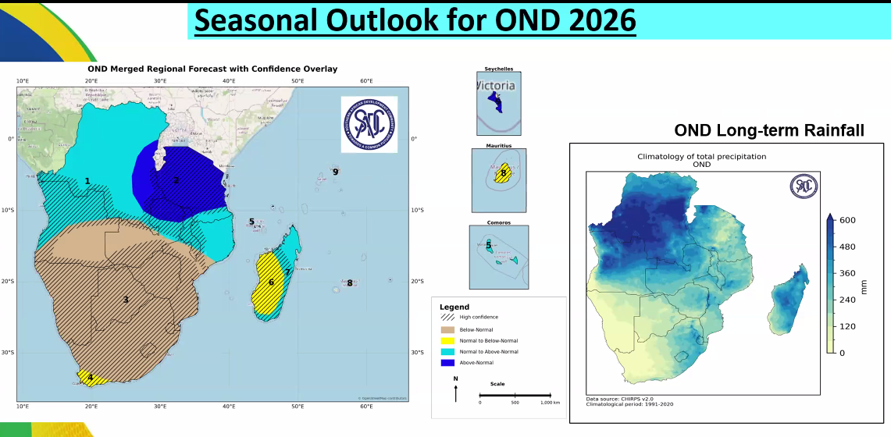
- Below normal rainfall is expected across much of Angola, southern Zambia, Zimbabwe, Mozambique, Namibia, Botswana, most of South Africa, Eswatini and Lesotho.
- Normal to below-normal rainfall is expected in Southwestern coastal South Africa, western and southwestern Madagascar and Mauritius.
- Normal to above-normal rainfall is expected in most of the Democratic Republic of Congo (DRC), northwestern Angola, northern Zambia, central Malawi and northern Mozambique, as well as the southern fringes of Tanzania, Comoros, North and Eastern Madagascar.
- Increased chances of Above-normal rainfall is expected in Eastern DRC, most of Tanzania, the extreme northern part of Malawi, extreme northern part of Zambia and Seychelles

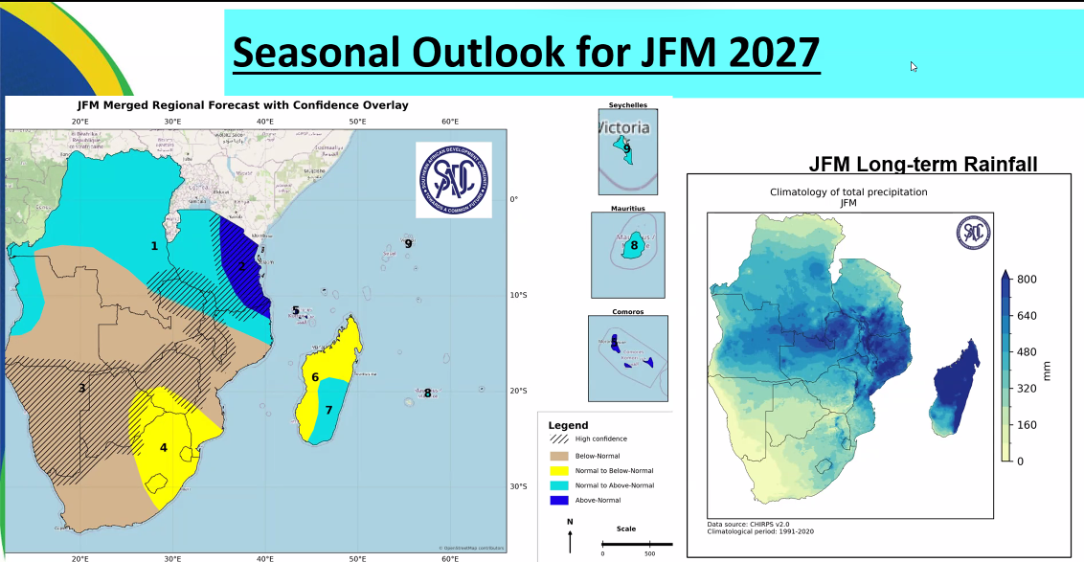
- Below-normal rainfall is expected in the southern DRC, bulk of Angola, bulk of Zambia, central and southern Malawi, central Mozambique, Namibia and bulk of Botswana, the western half of South Africa, and bulk of Zimbabwe.
- Normal to below-normal rainfall is expected in the eastern half of South Africa, Lesotho, Eswatini, southern Zimbabwe, extreme southern Mozambique and north and western Madagascar
- Normal to above-normal rainfall is expected in most of the Democratic Republic of Congo (DRC), extreme northwestern Angola, extreme northern Zambia, northern Malawi, northern parts Mozambique, western most of Tanzania, southeastern Madagascar, Mauritius, Seychelles.
- Above normal rainfall is expected in eastern Tanzania, extreme northern tip of Mozambique and Comoros.

- Temperature outlook for OND 2026/ JAN 2027
Temperature outlook for the period October 2026 to January 2027 indicates that temperatures are expected to be mostly above normal temperatures over most parts of SADC, except for central to to northeastern parts of the region where cooler than usual temperatures are expected.
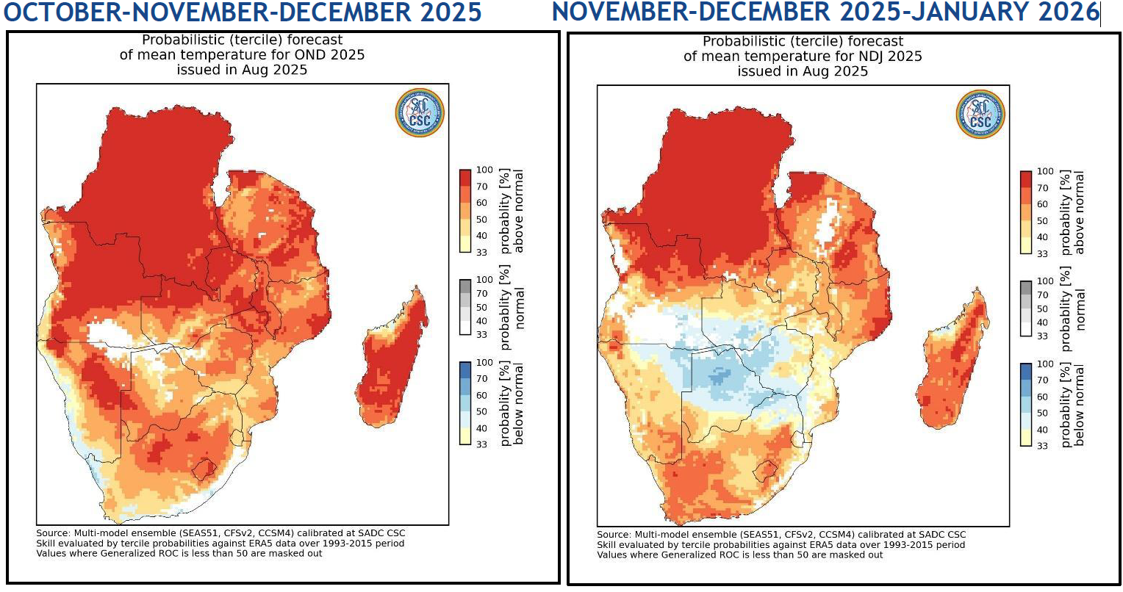

- TROPICAL CYCLONES ACTIVITY OUTLOOK IN SWIO region
Summary: Tropical Cyclone Activity Outlook for the SWIO/Southern Africa Region (2026/27 Season)
Preliminary Outlook Issued: RSMC La Réunion (Météo-France), 27 August 2026 — SARCOF-33.
Note: this is a first-guess, qualitative outlook; the final quantitative forecast will be issued by RSMC La Réunion in late October 2026, ahead of the TC mini-forum on 28 October (PIROI/WMO).
Key drivers shaping the outlook:
- A strong El Niño, developing positive IOD, and negative SIOD are all converging for the 2026/27 cyclone season.
- Historically, strong ENSO phases (either direction) tend to suppress overall TC activity in the South-West Indian Ocean, though the signal isn't fully systematic since IOD/SIOD also modulate it.
- El Niño and negative SIOD both favour a shift toward more meridional (south-easterly/southerly) track types and fewer zonal tracks — meaning storms are more likely to curve away to the southeast rather than track more directly westward toward the continent/Madagascar.
- Global Climate Model (GCM) steering-level (500 hPa) forecasts show enhanced cyclonic shear, consistent with the El Niño/IOD+ signal suppressing development and steering systems southward.
- ECMWF's tropical storm density forecast (SON, DJF 2026/27) shows a "reduced expected value" band across the core SWIO basin, including the Mozambique Channel and waters around Madagascar and Reunion/Mauritius.

Summary, Nov 2026–Apr 2027:
Aspect | Expectation
Overall activity | Below to strongly below average
Preferred track orientation | Southerly to south-easterly (fewer landfalling / zonal tracks)
Landfall risk – Madagascar & the continent (Mozambique, mainland Africa) | Below normal
First half of season (Nov–Jan) | Higher confidence — clearly driven by El Niño / IOD+ / SIOD-
Second half of season (Feb–Apr) | Too early to say — will hinge on how SIOD evolves

Practical implication: While the region should see a quieter-than-average cyclone season with reduced direct-hit risk, this is not a guarantee of no impactful storms — average climatology still puts landfall impacts at ~4.5/year across the basin, and confidence for the back half of the season remains low. This preliminary signal should be treated as indicative and revisited once RSMC La Réunion issues its full quantitative forecast in late October 2026.

